Morristown District Congregations Are Becoming More of What God Calls Them to Be

Can the United Methodist denomination creatively resource congregations in cohorts for revitalization and rethinking? Dr. Victor Dingus, PE, FELLOW, DMin. thinks so!
He recently wrote, as Methodism seeks to revitalize itself, we must be careful to invest our resources and our creativity and imaginations in the places where we have strength. We must remember that a large portion of the population of the country lives in small rural communities that cannot be effectively served by larger churches. Among the major denominations that offer a vital and balanced witness to the Christian faith, the Methodist movement continues to be is uniquely well equipped to serve people in both urban and rural communities alike. We have inherited from previous generations a network of churches that have placed a building and a congregation of some size in almost every crossroads community in the country. The members of those congregations are deeply committed to their churches.
The Morristown District realizes that local congregations are always evolving. However, a significant number of congregations measure vitality when self-esteem is distorted, damaged, or somewhat hidden. Research reflects that this mindset causes a loss of identity and a sense of purpose. Too often the small member congregation accepts the self-image dictated by society and the dominant culture. The Morristown District congregations are being challenged to reclaim that identity by discovering where God is working in their communities today, thus joining God in that ministry.
It is clear that the leadership of the District believes to the core of their being that NOW is the right time for congregations to examine themselves and ask the difficult questions about what is needed to be a faithful and an effective community of faith in order to have a promising future. The District leaders have determined in this moment of time to encourage and inspire this core belief and equip congregations to practice the appropriate approaches and strategies that will fulfill their potential and meet the world’s needs.
Tom Ballard, the Morristown District Superintendent, is convinced that the Holy Spirit is continuing to move in the lives of individuals and congregations. “This journey of faith is in keeping with the biblical thread of God’s people realizing that they must ultimately depend upon God to be with them step by step toward a Promised Land. For Moses and Joshua, it became the kingdom of Israel. For the Church, it is understanding the Kingdom of God which Jesus Christ initiated and invited his followers to spend a lifetime fulfilling. It is about local churches remaining connected within while at the same time turning to a world in need of the Good News of God’s redemptive love through the life, death, and resurrection of Jesus Christ,” says Ballard.
The District has begun to equip three faithful congregations, Bethel UMC in downtown Morristown, Mt. Zion Afton UMC in rural Greene County, and Strawberry Plains UMC, located near the convergence of Knox, Jefferson, and Sevier Counties, to imagine what God desires. These congregations are living into the Next Steps Ministry Now (NSMN) and bearing fruit as a result. Bethel has claimed the neighborhood adjacent to the facility and is striving to recreate their children’s programming and serve children’s needs. Mt. Zion Afton, in partnership with a local Church of God congregation, has claimed the Greene County jail, whereby they are serving the children and families of inmates and intentionally building relationships. At this time they are serving approximately 250 children. The Strawberry Plains congregation is reaching out to families and extending their love of this community to meet even more underserved needs by having on-going conversations with the community K-8 school. The principal and vice-principal are on-board.
NSMN is likened to a pilgrimage for these leaders and the at-large congregation as a whole. The pilgrimage is a process of cultivating and resourcing leadership and allows people to find a place they would not find to on their own.
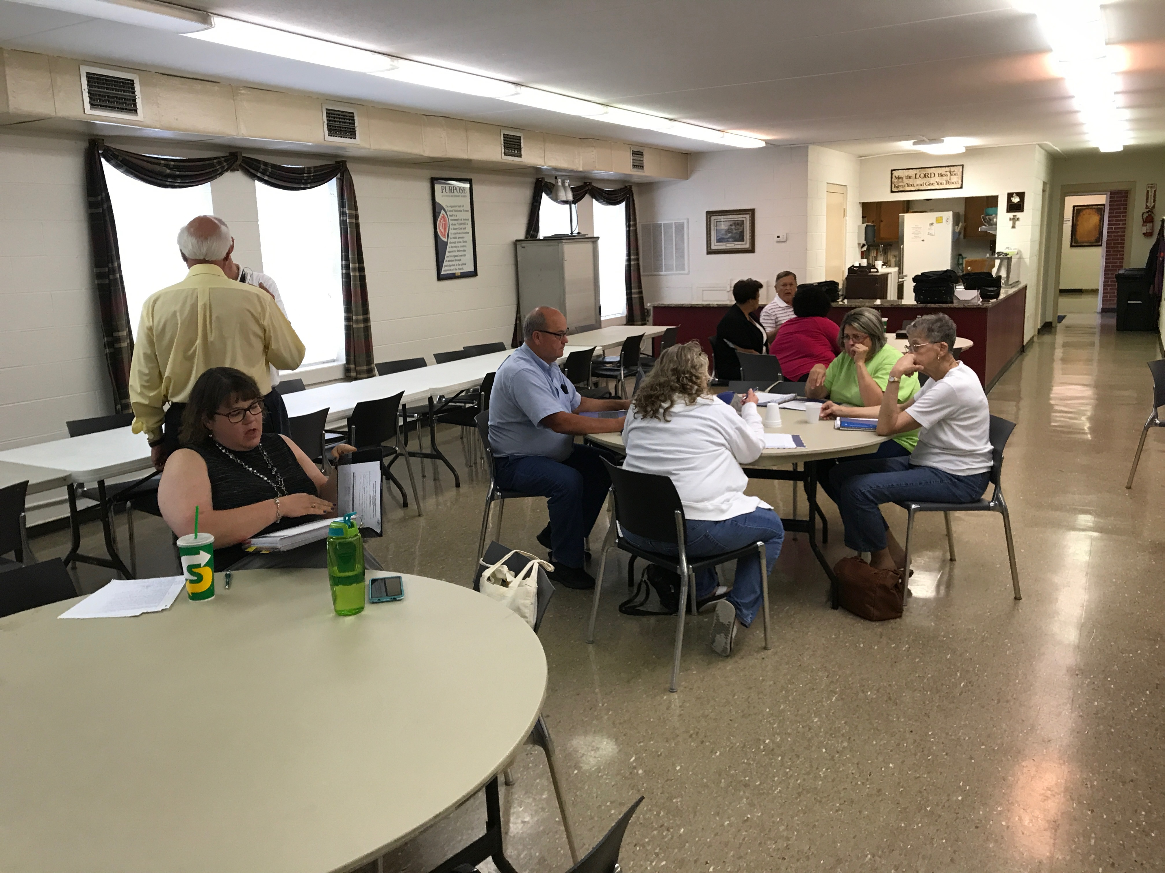
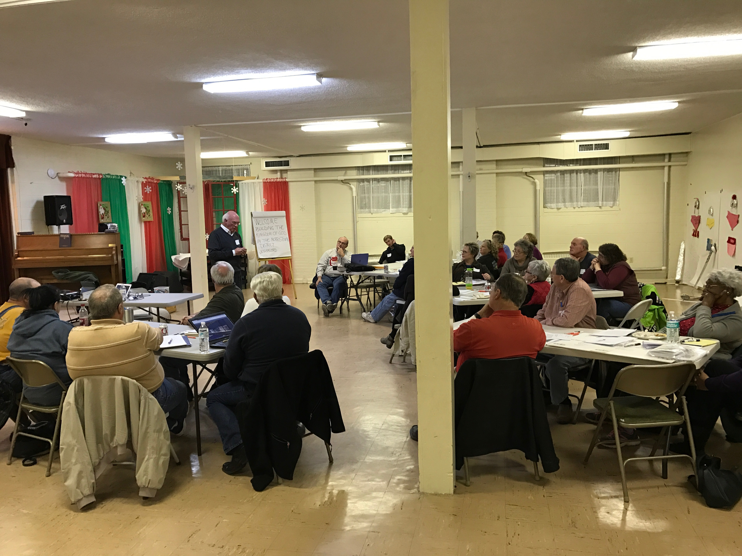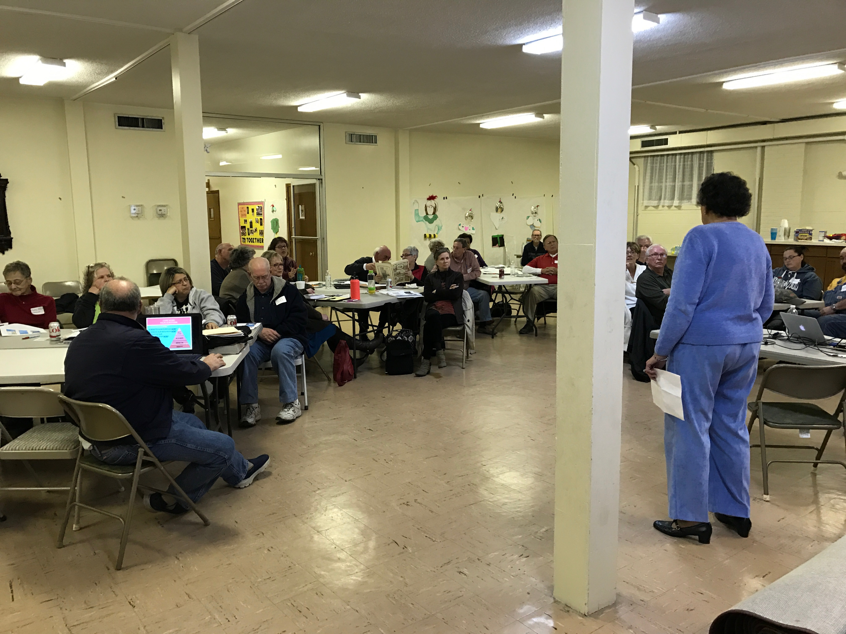
We Methodists have the structure, connection, message, and people to make disciples and transform communities. Congregational leaders are leaping into their imaginations by considering the emerging community context, their legacy, and their missional task so that their discernment, planning, and the harvest are fruitful. Their legacy and story within their community leverages their unique distinctiveness right where they are located.

